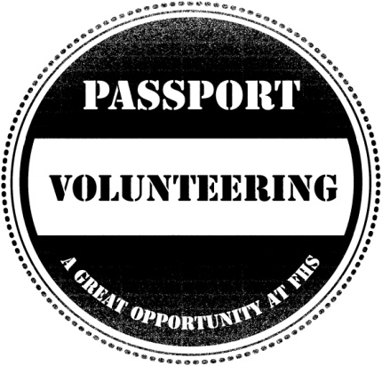
Community Volunteer Passport Scheme
Listed below are the volunteering opportunities available within the English department. Please contact a member of staff to find out how you can get involved.
Thank you for your help.
OPPORTUNITY | VOLUNTEERS NEEDED FROM YEAR GROUP | WHEN IS IT (IF APPLICABLE) | WHO CAN YOU CONTACT FOR DETAILS?
Designing and putting up displays in classrooms | Year s 7-13 | Before school, at lunchtimes, and after-school | Ms Eastwick  Ms Harvey  Ms Rumbelow
Stationary sorts  (ordering, colour-coding, sharpening pencils, etc) | Years 7-9 | Before school, at lunchtimes, and after-school | Ms Harvey
Creating literacy puzzles and games for registration | Year 7-13 | Before school, at lunchtimes, or after-school | Ms Mee
Organising, and distributing newspapers around B block | Years 7-13 | Before school | Ms Harvey
Classroom organisation | Years 7-9 | Before school, at lunchtimes, or after-school | Ms Ahluwalia  Ms Rumbelow
helpers for 7UP Games Club | Year 7 | Tuesdays Week A and B Lunch (period 5) | Ms Mee
Creating class resources  (wordsearches, spellings, etc) | Years 7-13 | Before school, at lunchtimes, or after-school | Ms Rumbelow  Ms Harvey
Help with literacy club | Years 9-11 | Lunchtimes P6 | Ms Eastwick
Collecting charity donations | Years 7-13 | Before school and lunch times | Ms Eastwick
In class English lesson support | 6th form | Periods 1 -7, outside volunteer’s timetabled lessons | Ms Mee
Preparing revision materials | Year 10-13 | Before school, at lunchtimes, or after-school | Ms Carey

