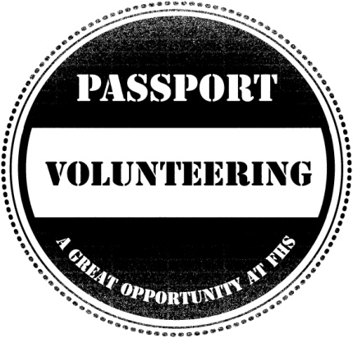
Community Volunteer Passport Scheme
Listed below are the volunteering opportunities available within the Psychology-Sociology department. Please contact a member of staff to find out how you can get involved.
Thank you for your help.
OPPORTUNITY | VOLUNTEERS NEEDED FROM YEAR GROUP | WHEN IS IT (IF APPLICABLE) | WHO TO CONTACT
Help with the display board | Yr12 – can be Art students as well as Soc | Week commencing 23/01/12 | Ms Ludlow
Help with sorting out worksheets, cards, etc. | Yr12 | Ongoing – every Mon/Tue am | Ms Ludlow

